**Financial inclusion Initiatives**

**Regulatory and Policy Measures**

1. **Community Reinvestment Act (CRA)**:
   * Enacted in 1977, the CRA requires banks to meet the credit needs of all segments of their communities, including low- and moderate-income neighborhoods.
   * Banks are evaluated on their efforts to provide loans, investments, and services to underserved areas.
2. **Dodd-Frank Wall Street Reform and Consumer Protection Act**:
   * Established the Consumer Financial Protection Bureau (CFPB) to protect consumers in the financial marketplace.
   * The CFPB works to ensure fair access to credit and financial products for all consumers.
3. **Financial Literacy and Education Commission (FLEC)**:
   * Coordinated by the Department of the Treasury, FLEC works to improve financial literacy and education among Americans.
   * Provides resources and programs to help individuals make informed financial decisions.

**Programs and Initiatives**

1. **Bank On Initiative**:
   * A national program led by the Cities for Financial Empowerment (CFE) Fund, promoting safe, affordable banking options.
   * Partners with financial institutions to offer accounts with low fees, no overdraft charges, and easy access.
2. **Earned Income Tax Credit (EITC) Awareness Campaign**:
   * A government initiative to increase awareness and uptake of the EITC, a refundable tax credit for low- to moderate-income working individuals and families.
   * Promotes financial stability and savings among eligible taxpayers.
3. **MyRA (My Retirement Account)**:
   * Launched by the U.S. Department of the Treasury, MyRA was a retirement savings program for workers without access to employer-sponsored retirement plans.
   * Aimed to provide a simple, safe, and affordable way to start saving for retirement.

**Technology and Innovation**

1. **Mobile Banking and Digital Financial Services**:
   * Banks and fintech companies offer mobile banking services, enabling access to financial services through smartphones.
   * Digital platforms provide tools for budgeting, savings, and credit building.
2. **Alternative Credit Scoring Models**:
   * Fintech companies and financial institutions are developing alternative credit scoring models using non-traditional data (e.g., utility payments, rent) to assess creditworthiness.
   * Helps individuals with thin or no credit files gain access to credit.

**Community and Grassroots Efforts**

1. **Volunteer Income Tax Assistance (VITA) Program**:
   * IRS-supported program offering free tax help to people with low to moderate income, persons with disabilities, and limited English-speaking taxpayers.
   * Ensures eligible taxpayers claim important tax credits and refunds.
2. **Community Development Financial Institutions (CDFIs)**:
   * CDFIs provide affordable financial services to underserved communities.
   * Offer loans, credit, and financial education to support small businesses, affordable housing, and community development projects.
3. **Financial Empowerment Centers (FECs)**:
   * Established in various cities to provide free, professional, one-on-one financial counseling.
   * Help residents reduce debt, increase savings, and improve credit scores.

**Education and Advocacy**

1. **Jump $tart Coalition for Personal Financial Literacy**:
   * A national coalition of organizations dedicated to improving financial literacy among students.
   * Provides resources, standards, and advocacy to promote financial education in schools.
2. **National Endowment for Financial Education (NEFE)**:
   * Provides financial education and resources to individuals and communities.
   * Focuses on improving financial capability and well-being through research and educational programs.

The good news is that financial inclusion has been on the rise across all demographics in U.S in 2013, 93% of all U.S households had a bank account, up from 86% in 1989.

**Significant Gains for Low-Income Households**:

* **1989**: 56% of households in the bottom income quintile had financial access.
* **2013**: Increased to 79%, showing a substantial improvement in financial inclusion for low-income households.

**Progress Among Minority Households**:

* **1989**: Approximately 65% of Hispanic and non-white households had financial access.
* **2013**: Increased to 87%, reflecting notable progress in financial inclusion for minority groups.

**Persistent Gaps in Financial Access**:

* Despite these improvements, there remain significant disparities in financial access for low-income and minority households.
* Policy interventions are needed to further bridge these gaps and ensure equitable access to financial services for all segments of the population.

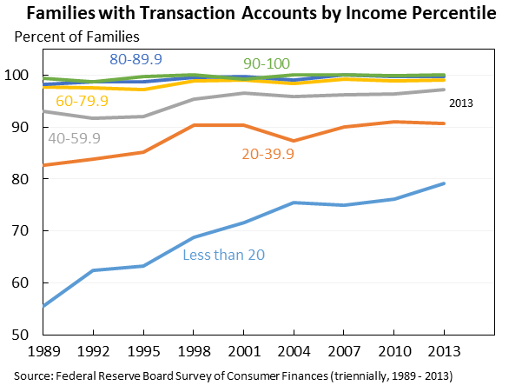

### **Financial Inclusion Initiatives in the United States**

1. **USAID’s Gender Equality and Women’s Empowerment 2020 Policy**:
   * Revised to prioritize gender equality and women’s empowerment, emphasizing financial inclusion for women.
2. **Bank of America’s $1 Billion/4-Year Commitment**:
   * Aimed at supporting economic opportunity initiatives, including financial inclusion.
3. **Business Roundtable’s Advancing Racial Equity and Justice Initiative**:
   * Focuses on promoting racial equity and justice, with a component dedicated to financial inclusion for underserved communities.
4. **Principal’s Inclusion in Our Communities**:
   * An initiative by Principal financial services company focusing on financial literacy and education in communities.
5. **OCC’s Community Reinvestment Act Rule Update**:
   * Updated in June 2020 to enhance financial inclusion and community development.
6. **Global Findex Database**:
   * A collaboration between the World Bank and the Bill & Melinda Gates Foundation providing data on financial inclusion, including access and usage of financial services.
7. **Federal Reserve System’s Financial Inclusion and Consumer Protection Service Line**: Offers country diagnostic reviews, household surveys, and technical assistance to strengthen frameworks for financial inclusion.

**They** aiming to increase access to safe and affordable financial services for underserved populations.

* **Mobile Money**: The US has seen the growth of mobile money services, allowing individuals to store and transfer funds using their mobile phones. According to a report by the Federal Reserve, in 2020, 39% of adults in the US used mobile banking, with 24% using mobile banking apps to make payments.
* **Bank Account Ownership**: The US has made progress in increasing bank account ownership among low-income households. According to the Federal Reserve’s Survey of Consumer Finances, in 2019, 93% of households in the US had a bank account, up from 84% in 2013.
* **Credit Building**: Initiatives like credit-builder loans and secured credit cards have been introduced to help individuals build credit. According to a report by the Federal Reserve, in 2020, 44% of adults in the US had a credit score, up from 38% in 2013.
* **Financial Education**: Financial education programs have been implemented to improve financial literacy and capability. The National Foundation for Credit Counseling (NFCC) provides financial education and counseling services to individuals.
* **Financial Inclusion Index**: The US has developed a financial inclusion index to measure the country’s progress in promoting financial inclusion. The index assesses access to financial services, usage of financial services, and the quality of service delivery.

**Key Statistics:**

* 93% of households in the US have a bank account
* 39% of adults in the US use mobile banking
* 44% of adults in the US have a credit score
* 24% of adults in the US use mobile banking apps to make payments

**Challenges and Areas for Improvement**

Despite these efforts, financial inclusion in the US still faces challenges, including:

* **Access to Bank Accounts**: Around 7% of American households lack access to a bank account, and 20% have a bank account but also use financial services associated with the financially excluded, such as payday loans.
* **Financial Literacy**: Many Americans lack basic financial literacy, making it difficult for them to make informed financial decisions.
* **Data Privacy and Security**: Concerns about data privacy and security continue to be a major obstacle to financial inclusion, particularly in the digital age.